Self Service manual for non emergency Service Requests
Questions please system administrator at 541-346-2276 or FASSIT@uoregon.edu

Enter user name and password

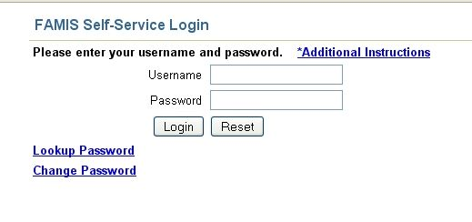
Enter user name
Enter password

Use scroll bar at right to locate your building. Click on building number or scroll
to end of list to locate Service Requests box. (if multiple buildings or building not applicable continue with Service Requests)

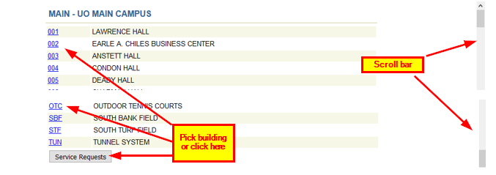

Once in the Service Requests page you can:
- Check Service Requests Status
- Create a new Service Request
- Check billing history
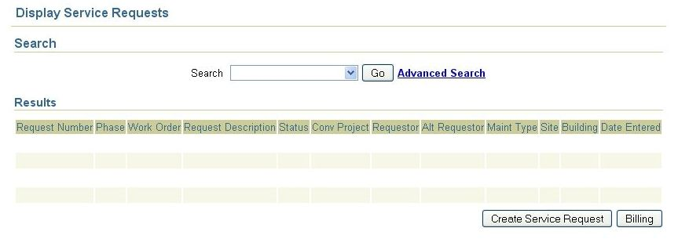
New Service Request
Billing history
Check Service Request status

Check Service Requests Status
Click on down arrow on right side of Search box and choose one option. Click Go. Now you can view status of your service requests.

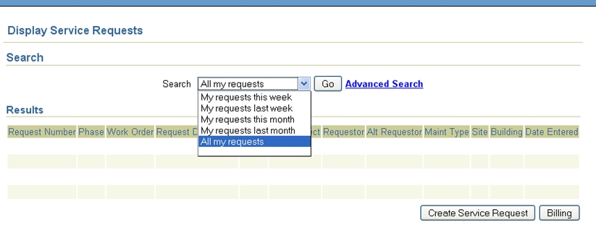

Create a Service Request
Click the Create Service Request box bottom right. In the following screen, click on type of service requested or click “create you own request” if none of the other choices are applicable.
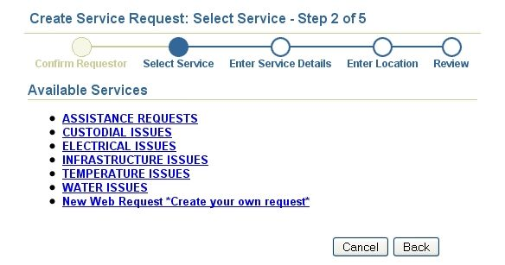

On the Enter Service Details page, enter index, account code if you know them, pct (percentage) enter 100 unless more than one index is paying for the work. Index and account letters must be in upper case. Bldg maintenance and repair account code is 23502.
You may click on the Index and Account boxes for a full menu of account codes or index numbers. If CPFM provides this service, leave accounting information blank and fill out the rest of page.
Enter a work title that describes the problem or request in the Work Title text bo and type a more detail/specific description of the problem/request in the Description of Work text box.
Start and Completion Dates are optional entries. Finally click on the Next button.

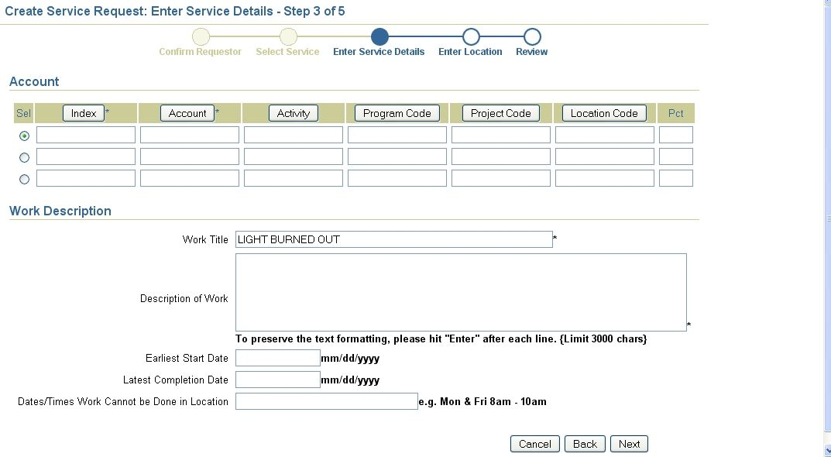

On the Enter Location page, confirm or add building if applicable. Click Next.

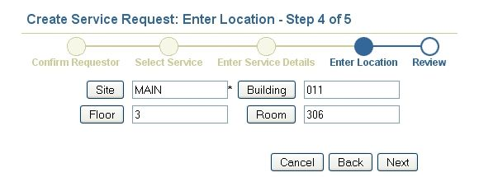

On the Review page confirm all information submitted is accurate. By clicking Cancel, no Service Request will be generated. Click back button in your web browser if you need to edit data. Click Finish and a Service Request number will be generated. To cancel request after this, call Customer Service at 541-346- 2319.

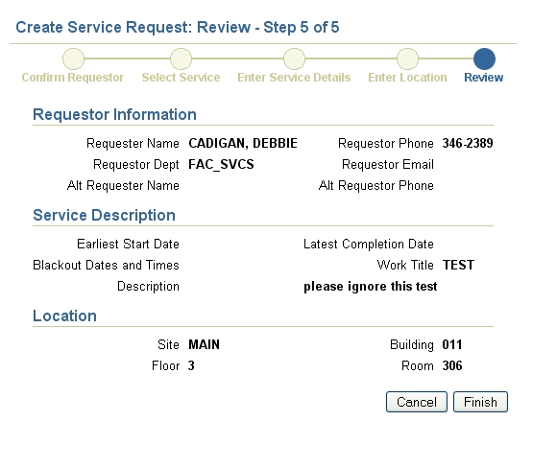
Once customer service center receives this request, reviews and schedules it, a work order number is issued to the request. This page shows your Service Request number at the top. Feel free to print out for your records. You may reference either number when contacting us

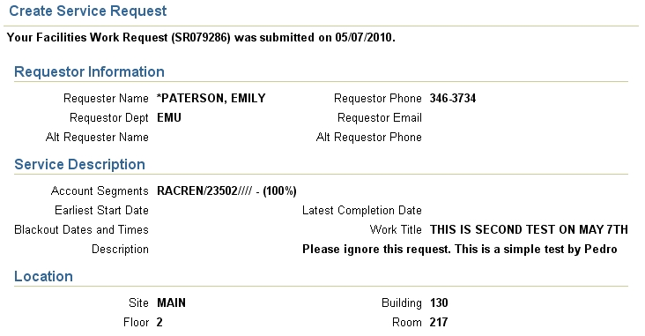

Checking billing history

Click on Billing box (bottom right on Service Request page) to go to the billing page. Enter index (must be in upper case) and specify dates. Click Search button.
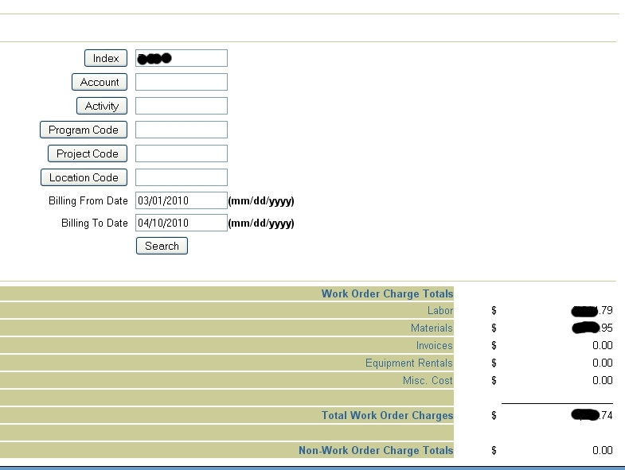
Enter index and the dates.

Keep in mind that you may need to scroll down in order to see all the service requests/work orders related with the index you entered. In order to see the specifics of a work order click on one the work order.

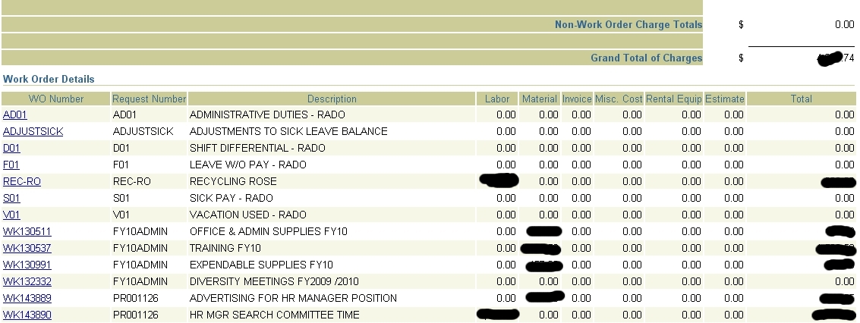
Locate and click on the WK you want

In order to print your report right you need to do the following:
If you are using FireFox: right click on anywhere in the WO Number column. Locate the This Frame option in the subsequent menu. Click on Print Frame in the submenu.
If you are using Internet Explorer: Right click in any place of the page except on the WO Number column. Click on Print… Click on the Options tab and check that the “Only the selected frame” option is checked. Click Print and that’s it. You may want to change the page orientation as well (the report is printed better horizontal).

